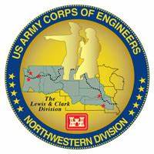
Columbia River System (CRS) Fish Facility Design Review Work Group (FFDRWG)

USACE, Portland District (NWP) and Walla Walla District (NWW)
  - March 2024 Meeting Agenda
Meeting Date: May 2, 2024, 12:30-15:00
Webex: https://usace1.webex.com/join/jacob.macdonald
FFDRWG Meeting Files:
https://pweb.crohms.org/tmt/documents/FPOM/2010/FFDRWG/FFDRWG.html

FFDRWG contact list
BPA
Scott Bettin
Christine Petersen
Leah Sullivan
Ben Hausmann
Carolina Andes
Josh Ashline
Tammy Mackey
NOAA
Blane Bellerud
Gabriel Brooks
Trevor Conder
Claire McGrath
Kelsey Swieca
Chris Magel
Kinsey Frick
Dana Bethea
USFWS
Dave Swank
Shelby Fowler
Joe Skalicky
States
Erick Van Dyke (ODFW)
Ben Clemens (ODFW)
Charles Morrill (WDFW)
Jonathan Ebel (IDFG)
CRITFC/Tribes
Tom Lorz (CRITFC)
Laurie Porter (CRITFC)
Greg Silver (CRITFC)
Casey Baldwin (CTCR)
Michael Karnosh (CTGR)
Lawrence Schwabe (CTGR)
Torey Wakeland (CTGR)
Aaron Jackson (CTUIR)
Ralph Lampman (YN)
Tod Sween (NPT)
Lyman Jim (CTWS)
NPCC
Kris Homel
FPC
Erin Cooper
Noah Campbell
PSMFC
Alan Brower
Darren Chase
Roger Clark
Mark Leonard
Scott Livingston
Nicole Tancreto
Don Warf
CENWD
Doug Baus
Tim Dykstra
Dan Feil
Cindy Studebaker
Lisa Wright
Sean Tackley
Ian Chane
CENWP-PM
Ida Royer
Erin Kovalchuk
Mark Bierman
Brad Eppard
Nathan McClain
Jake Macdonald
Jon Rerecich
David Trachtenbarg
Scott Fielding
Rebecca Cates
CENWP-OD
Andrew Derugin
Jeanette Flemmer
Tucker Gossett
Jaselyn Owens
Bob Cordie
Eric Grosvenor
Jeffrey Randall
Aaron Young
David Miller
Michael Lotspeich
Laura Rickets
Robert Wertheimer
Patricia Madson
Darren Gallion
Kyle Tidwell
CENWP-ENC
Adam Jones
Adam White
Brandt Bannister
Shari Dunlop
Chris Motti
Steve Schlenker
Max Wilson-Fey
Collin Porter
Dan Penn
Aaron Litzenberg
Mehdi Roshani
Cole Marfise
CENWW-PM
Chuck Barnes
Steve Juhnke
Steve Sipe
Ricardo Walker
Brad Trumbo
Liana Aker
Michael Erickson
Karen Zelch
CENWW-OD
Chris Peery
Tiffany Stoeckig-DixoN
Denise Griffith
Elizabeth Holdren
Ken Fone
Bobby Johnson
Deb Snyder
CENWW-ENC
Jon Renholds
Sean Milligan
Ryan Pestes
Travis Foster
John Lomeland
Ryan Laughery

Action items from previous meetings

Macdonald: Jake will schedule a tour of The Dalles East Fish Ladder LPS

Not complete yet. Will attempt to reschedule in Spring, after water-up, when there are fish.

Macdonald: Jake will schedule a Webex call for interested FFDRWG and FPOM participants with relevant experience to help CRITFC/Tribes develop a video monitoring plan for when the floating lamprey collector prototype is being tested at The Dalles Dam.

Not complete yet.

NWP Topics for FFDRWG Update/Review/Coordination

NWP BON1 adult lamprey passage improvements – Erin Kovalchuk (PM), Adam White (TL), Jake Macdonald (FFDRWG)

NWP BON2 control section redesign – Erin Kovalchuk (PM), Adam White (TL), Jake Macdonald (FFDRWG)

NWP TDA adult lamprey passage improvements – Erin Kovalchuk (PM), Adam White (TL), Jake Macdonald (FFDRWG)

NWP JDA adult lamprey passage improvements – Erin Kovalchuk (PM), Adam White (TL), Jake Macdonald (FFDRWG)

ML: Elevator contractor is on site. Began work around 17-Apr, estimated 6 weeks to get it done. Hoping elevator will be done by 1-June.

NWP BON1 PIT Detection – Mark Bierman (PM), Jeanette Flemmer (FFDRWG)

100% design review is scheduled to start end of July. Final reviewed product to customer mid-late September.

NWP floating adult lamprey trap for tribal translocation (*partner project; not a USACE design) – Ralph Lampman (TL), Jake Macdonald (FFDRWG)

Waiting for final real estate permission to enter CBB. Should start soon.

NWP BON Spillway rock mitigation – Marie Adams (PM), Adam Jones (TL), Rebecca Cates (FFDRWG)

No update currently.

FFDRWG “mitigation” project is the barriers on the spillway apron, not rock “removal”.

TL: Schedule? SF: think construction is scheduled for next year but will verify.

NWP TDA Backup AWS debris management – Erin Kovalchuk (PM), Mehdi Roshani (TL), Jon Rerecich (FFDRWG)

Update next FFDRWG.

NWW Topics for FFDRWG Update/Review/Coordination

NWW IHR Turbine Cooling Water Exclusion - Karen Zelch (PM), Liana Aker (Bio)

Advertised construction/installation in April. Planned installation in unit 6 in October. No interested contractors. No word on delay yet, but expected. Looking into in-house capability. Chuck will keep FFDRWG updated.

NWW MNA Turbine Replacement Design – Jean Desjarlais (PM), Jon Renholds (TL)

Jon Renholds - MNA turbine replacement update
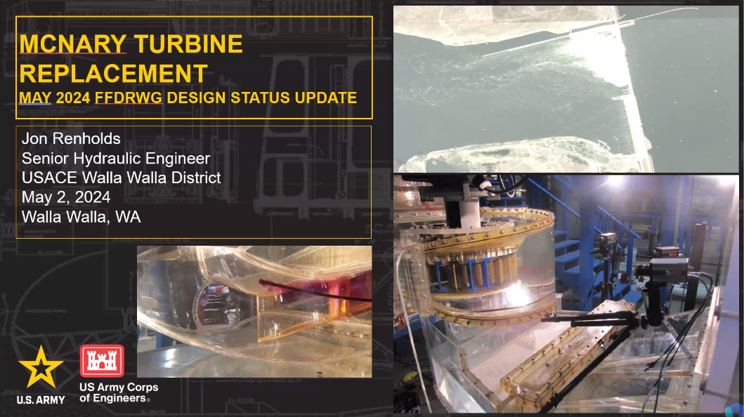
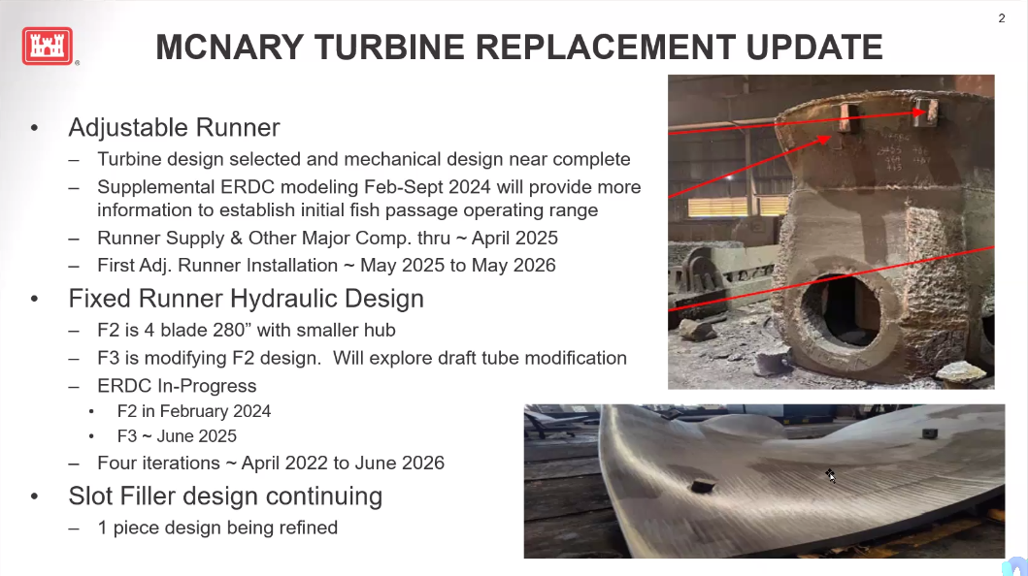
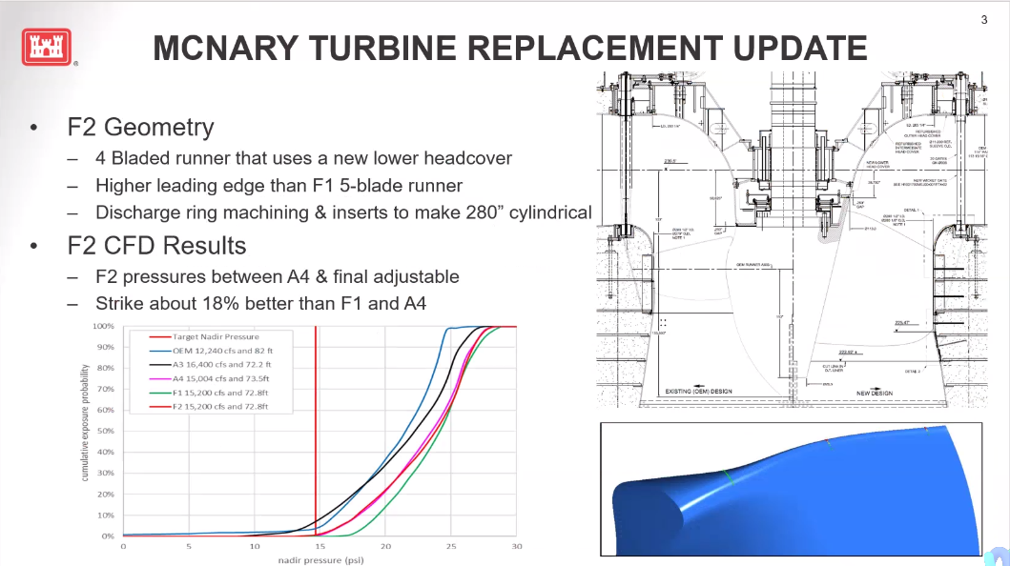
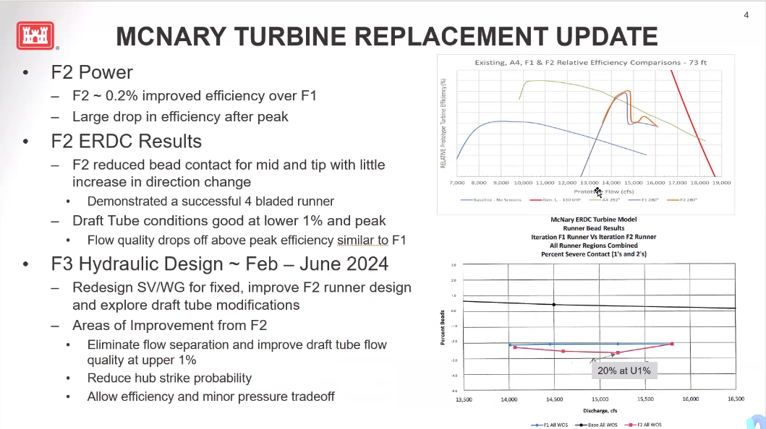

NWW MNA Draft Tube Slot Filler – Jean Desjarlais (PM), Jon Renholds (TL), Chuck Barnes (Bio)

Jon Renholds - MNA draft tube slot filler update
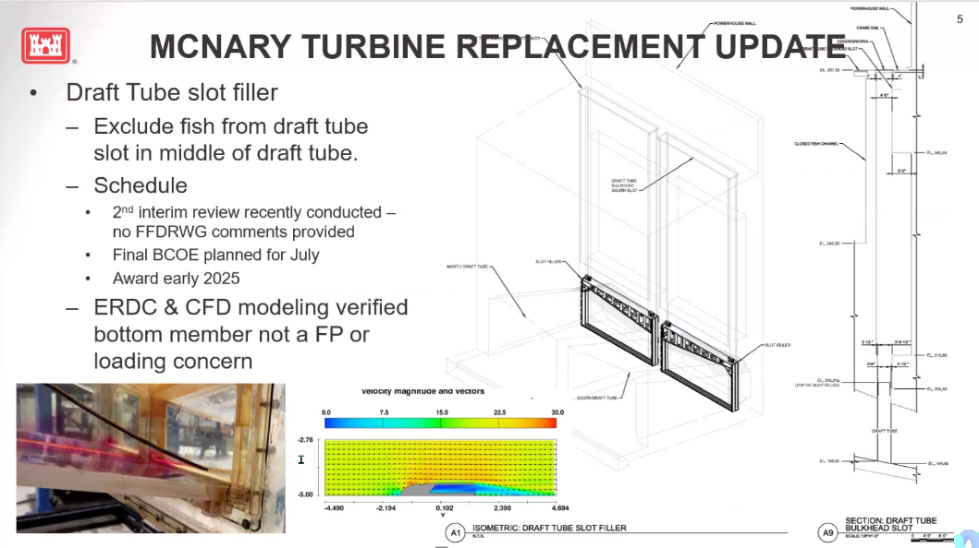
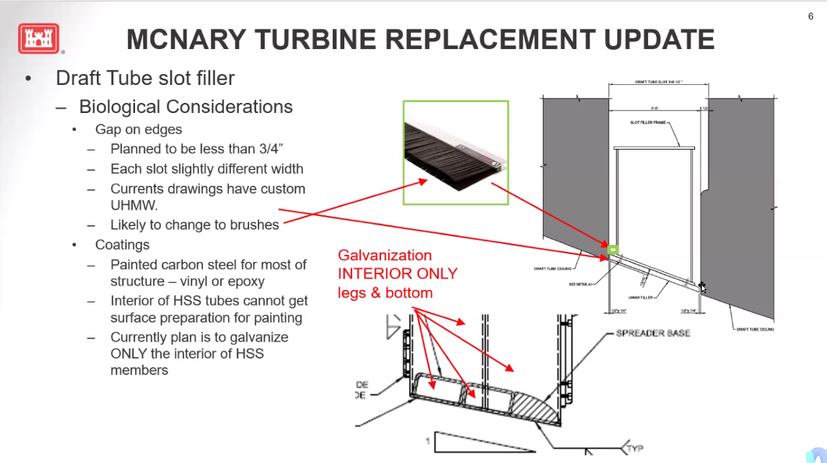

CM: Can components be dipped to coat the inside prior to fabrication? JR: Yes.

NWW LGA Adult Ladder Cooling Chimney Flap Gate- Karen Zelch (PM), Chuck Barnes (Bio)

Complete. Remove from FFDRWG agenda.

NWW LLA Adult Ladder Turn Pool Gate - Greg Linklater (PM), Chuck Barnes (Bio)

On schedule

NWW Lower Granite cooling pumps – (PM yet to be determined)

FPOM project. Remove from FFDRWG agenda.

NWW MCN Avian deterrence – Karen Zelch (PM)

PM not available today. A/E contract for alternatives analysis to be awarded in June. Update at next FFDRWG.

NWW MNA PIT Detection – Karen Zelch (PM)

Project has kicked off. Update at next FFDRWG.

NWW John Day Dam and Snake River Ladder Cooling – Karen Zelch (PM)

A/E contract (MATOC) for alternatives evaluation. Architectural/Engineering (unique contract type for licensed professional engineering services). Multiple Award Task Order Contract (pool of pre-qualified A/E contractors).

Upcoming meetings and field trips

Next regularly scheduled NWW/NWP FFDRWG meeting – Thursday, June 6th @ 09:00

Send suggestions for agenda items to Jake Macdonald and Chuck Barnes

Field trip for FFDRWG and Corps-Tribal Lamprey Work Group to see floating lamprey collector in operation.

Partial day, In-person site visit to Tanner Creek hatchery – CRITFC/Tribes will schedule when they’re ready (April-May)

Partial day, In-person site visit to The Dalles Dam – Jake/CRITFC/Tribes will schedule when ready, later in the 2024 fish passage season.

Field trips for FFDRWG and Corps-Tribal Lamprey Work Group to see adult lamprey passage improvements in operation.

Bonneville Dam Bradford Island B-branch Entrance – Jake will schedule during the peak of the 2024 fish passage season.

The Dalles East Fish Ladder junction pool LPS – Jake will schedule together with 5.2.2.

John Day North Fish Ladder Entrance LPS - Jake will schedule during the peak of the 2024 fish passage season.

